Hi Team,

Issue: User unable to take RDP from his local machine, User will get below error message

De ktop n 
An authenticaticm er;-or has occurred. 
The function requested is not supported 
Rernote computer. 52.172.222.80 
This ccu_jld be due to CredSSP encryption oracle remediation. 
i n kid: 

Description: The issue is due to Security CredSSP vulnerability patches in Windows.

Resolution:

As workaround we need to edit the registry value in his local machine.

Before editing the registry value kindly take backup.

You can naviagte till the System , Right Click on the System and Select New—Key---Input Value—CredSSP-----Create New Key------Parameters

Below are the screenshot for reference

**[HKEY\_LOCAL\_MACHINE\SOFTWARE\Microsoft\Windows\CurrentVersion\Policies\System\CredSSP\Parameters] “AllowEncryptionOracle”=dword:00000002**

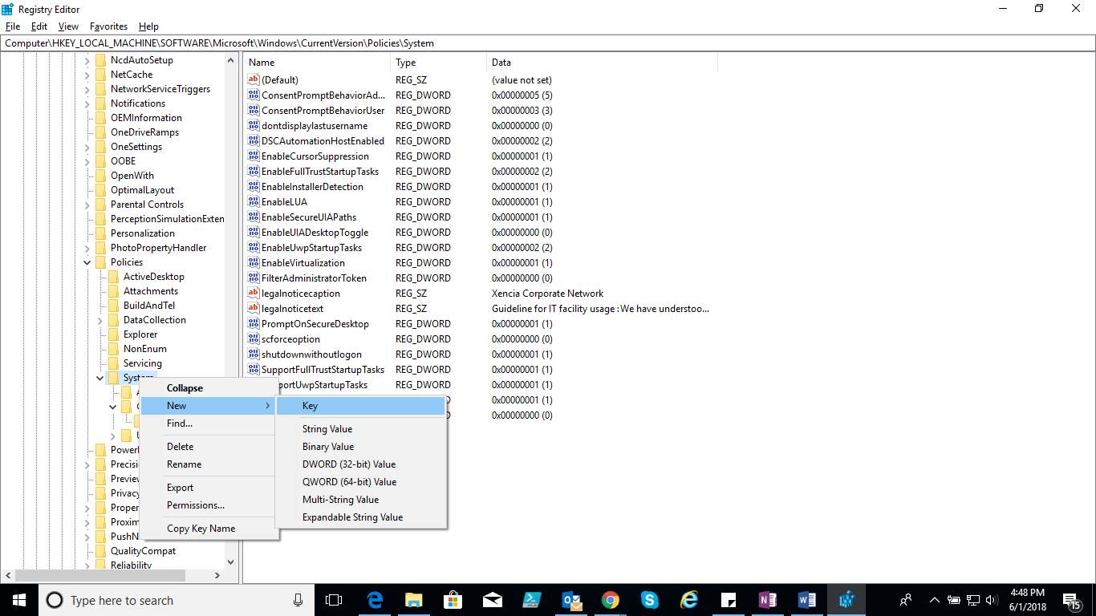

Computer\HKEY LOCAL 
NetworkServiceTriggers A Name 
Notifications 
OEMInformation 
OneDriveRamps 
OneSettings 
OOSE 
OpenWith 
OptimalLayout 
Parental Controls 
PerceptionSimuIationExtf 
Personalization 
PhotoPropertyHandIer 
Policies 
ActiveDesktop 
Attachments 
8uiIdAndTeI 
DataCoIIection 
Explorer 
NonEnum 
Servicing 
v System 
Audit 
v creassp 
Paramete 
(Default) 
AllowEncryptionOracIe 
Type 
REG SZ 
REG DWORD 
(value not set) 
DxDDDDDD02 (2) 

In the right pane

Right click select New------DWORD change the DWORD value to “**AllowEncryptionOracle”**

Computer\HKEY LOCAL 
NetworkServiceTriggers A Name 
Notifications 
OEMInformation 
OneDriveRamps 
OneSettings 
OOSE 
OpenWith 
OptimalLayout 
Parental Controls 
PerceptionSimuIationExtf 
Personalization 
PhotoPropertyHandIer 
Policies 
ActiveDesktop 
Attachments 
8uiIdAndTeI 
DataCoIIection 
Explorer 
NonEnum 
Servicing 
v System 
Audit 
v creassp 
Parameters 
PowerEfficiencyDiaqnost 
el (Default) 
AllowEncryptionOracIe 
Type 
REG SZ 
REG DWORD 
(value not set) 
DxDDDDDD02 (2) 
Key 
String Value 
Binary Value 
OWORD (32-bit) value 
QV.'ORD (64-bit) value 
Multi-String Value 
Expandable String Value 

Double Click on the “**AllowEncryptionoracle”** to edit the DWORD value data to 2

Below screen shot for reference.

